FOSSOWAY & DISTRICT COMMUNITY COUNCIL
WIND FARM SURVEY REPORT
30TH JANUARY 2024

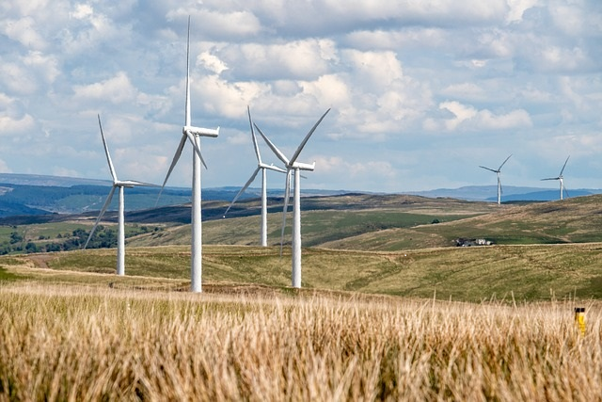
CONTENTS
Introduction 4
Results 5
Responses to Q1 - Were you already aware of the current wind farm proposals at Brunt Hill and Craighead? 5
Responses to Q2 - Have you attended any of the engagement events and if so, which ones? 5
Responses to Q3 - Do you generally support renewable energy (i.e., energy generated by wind, wave, sun, or ground/air heat source)? 6
Responses to Q4 - Do you generally support onshore wind farms? 7
Responses to Q5 - Do you specifically support the wind farm proposals in the Ochils? 8
Responses to Q6 - Why do you hold this view? 10
Responses to Q7 - Which community do you live closest to? 14
Responses to Q8 - Tell us about your views of these proposals in the construction phase. 14
Responses to Q9 - Tell us about your views in the operational phase 16
Responses to Q10 - If these proposals go ahead, there will be a community windfall; how would you like to see that money spent? 18
Conclusion 21
Appendices
Appendix 1 22
Responses to Q6 - Why do you hold this view?

Appendix 2 37
Responses to Q8 - Tell us about your views of these proposals in the construction phase.
Appendix 3 46
Responses to Q9 - Tell us about your views in the operational phase.
Appendix 4 53
Responses to Q10 - If these proposals go ahead, there will be a community windfall; how would you like to see that money spent?

INTRODUCTION
To help the Fossoway District Community Council represent you, we carried out a survey to know what you think about the proposed wind farm developments in Fossoway District

- Do you support or oppose wind farms?

- How can disruption be reduced or mitigated?

- How should the Community use any financial benefit?

PROPOSED WIND FARMS

- Brunt Hill (E-Power) is located approximately 5km north-west of Kinross. The current proposal is 18 turbines with a maximum blade tip height of 200m which will generate up to 130MW of energy with 65MW of battery storage. For more details see E-Power’s website at: https://brunthillinfo.co.uk/

- Craighead Farm (Galileo) is located approximately 6km north-west of Carnbo. The current proposal is for 8 turbines with a maximum blade tip height of 200m which will generate up to 48MW of energy. For more details see Galileo’s website at: https://craigheadwindfarm.co.uk/

SURVEY

The survey was distributed to all 939 occupied households in the Fossoway District by volunteers. Residents could either complete the survey online or by paper copy dropping them in locations across the district. The survey was open from the 1st to the 30th November 2023. The Community Council committed to producing a report of all responses and share the results with the community at a public meeting which was held in Carnbo Village on the 30th January 2024
RESULTS
We received a total of 110 responses, 22 were handwritten and 88 were online. This represents 11.7% of the Community.

- Were you already aware of the current wind farm proposals at Brunt Hill and Craighead?
Despite extensive advertising of the proposed wind farm developments on social media by the Community Council and the topic being a standard agenda item on more than six months of our meetings only 62.7% of residents were aware of the proposals. If this is extrapolated to the entire 939 households then 350 households were unaware of the proposed wind farms before the survey was distributed. This alone justifies the hand delivery of the survey to all households in the Fossoway District.

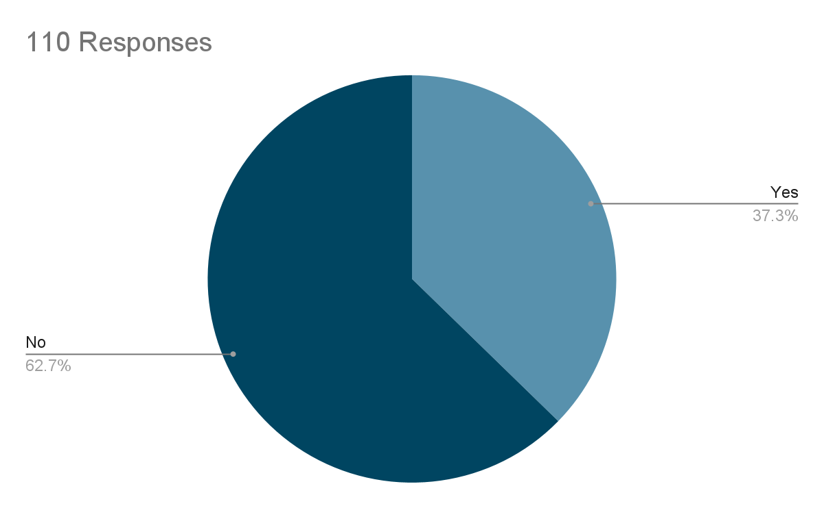
- Have you attended any of the engagement events and if so, which ones?
As of November 2023 there had been nine opportunities for residents to attend an event to learn more about the proposed wind farms. However 82 (74.5%) of responders to the survey had not attended any of these events. Engaging with residents on future proposals and the progress of the current proposed developments will continue to be challenging for the Community Council.

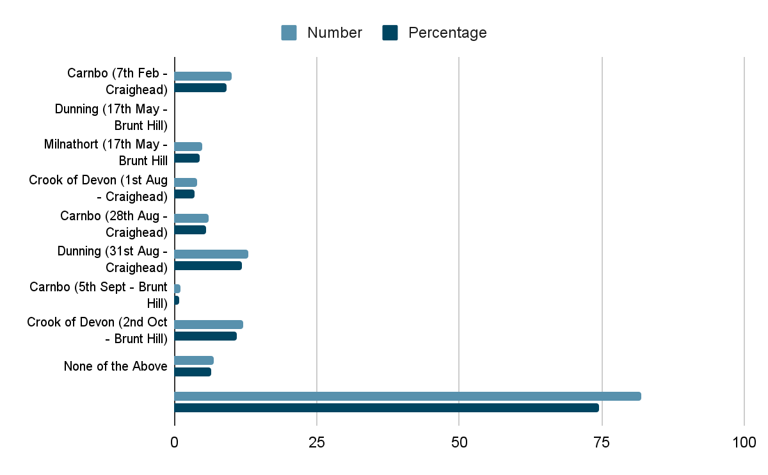
- Do you generally support renewable energy (i.e., energy generated by wind, wave, sun, or ground/air heat source)?

Response | Number | % of Total
Strongly Support | 62 | 56.4
Support | 36 | 32.7
Undecided | 5 | 4.5
Oppose | 2 | 1.8
Strongly Oppose | 5 | 4.5
Total | 110

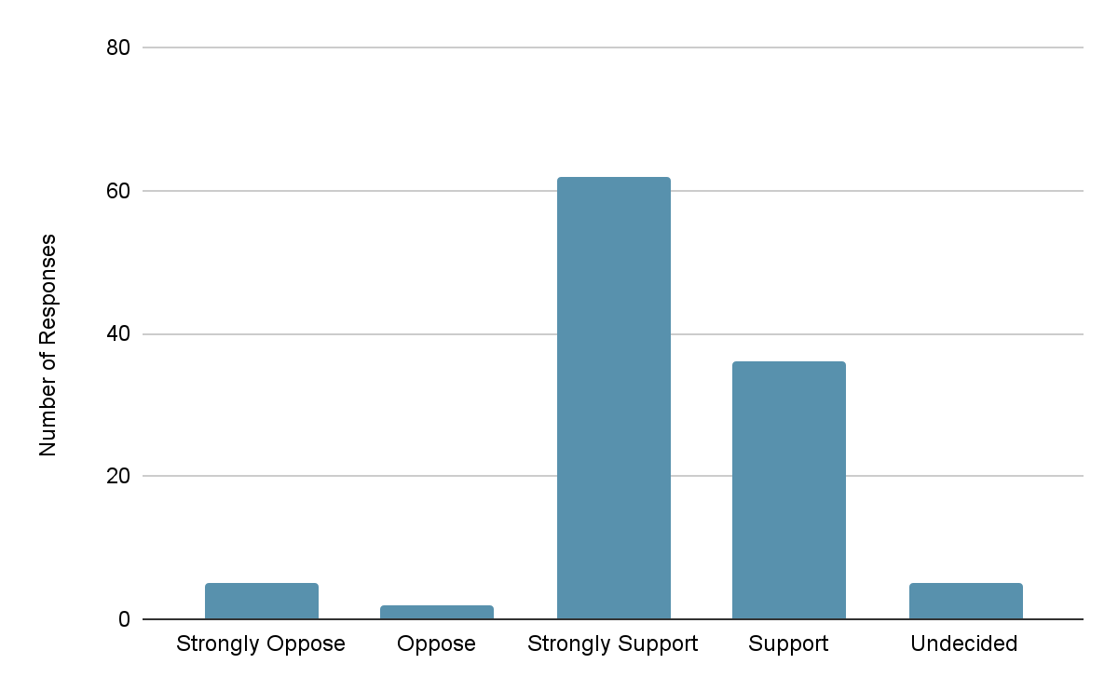
The vast majority of residents (89.1%) are supportive of renewable energy with only a small percentage (6.3%) opposing any form of renewable energy.
- Do you generally support onshore wind farms?
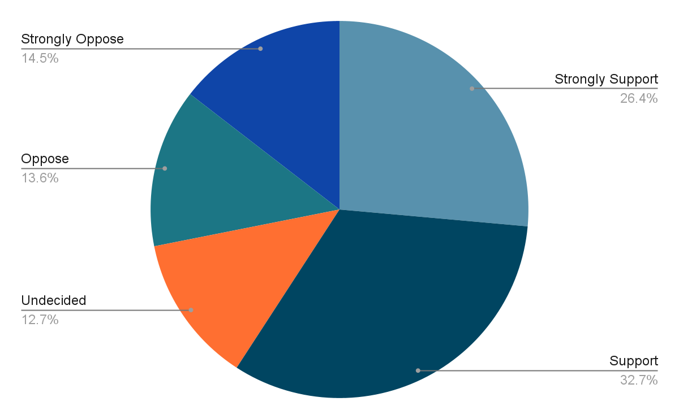

Response | Number
Strongly Support | 29
Support | 36
Undecided | 14
Oppose | 15
Strongly Oppose | 16

When asked about their views of onshore wind farms, residents were less supportive with only 59.1% supporting them compared to the 89.1% that were supportive of renewable energy. The percentage of those that opposed onshore wind farms was 28.1% which is 24 more residents than the number that opposed renewable energy.

- Do you specifically support the wind farm proposals in the Ochils?

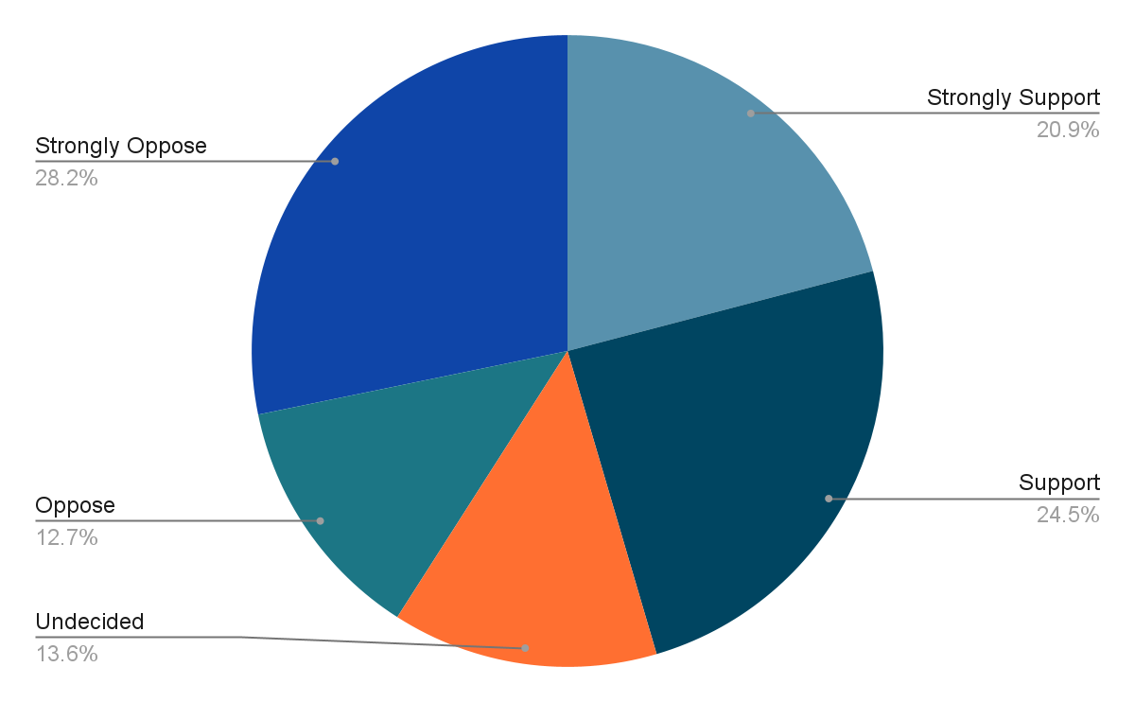

Response | Number
Strongly Support | 23
Support | 27
Undecided | 15
Oppose | 14
Strongly Oppose | 31

There were fewer residents supportive of wind farms in the Ochils with the level of support dropping from 59.1% who were supportive to onshore wind farms to only 45.4% supporting wind farms in the Ochils. As expected the level of opposition increased from 28.1% to 45%. This means that as a Community the Fossoway District is roughly evenly split between supporting and opposing wind farms in the Ochils.
When considering the results by settlement then it is clear that in Carnbo, the closest settlement to the proposed wind farm developments, there are more residents that oppose (60%) the wind farms than support (34%). However there were only 19 households that responded from Carnbo. Residents in settlements further away from the proposed developments were more evenly split on their views.

Results by Settlement
 | Strongly Support | Support | Undecided | Oppose | Strongly Oppose
Blairingone | 6 (33%) | 1 (6%) | 3 (17%) | 1 (6%) | 7 (39%)
Carnbo | 1 (7%) | 4 (27%) | 1 (7%) | 4 (27%) | 5 (33%)
Crook of Devon | 10 (26%) | 9 (24%) | 5 (13%) | 4 (11%) | 10 (26%)
Drum | 4 (36%) | 2 (18%) | 1 (9%) | 2 (18%) | 2 (18%)
Powmill | 2 (11%) | 7 (39%) | 1 (6%) | 3 (17%) | 5 (28%)
Rumbling Bridge | 0 | 3 (60%) | 1 (20%) | 0 | 1 (20%)
Elsewhere in Fossoway | 0 | 1 (20%) | 3 (60%) | 0 | 1 (20%)

- Why do you hold this view?
There were 105 responses to this question equating to 95% of total responders.

Summary Blairingone - 17 Responses
There was a lot of commonality in residents' views on the proposed location of wind farms in the Ochils. Those opposing them are concerned about the detrimental effect on the landscape citing the Scottish Government's strategy on promoting tourism and that this would have an adverse effect on it. It was also pointed out that nuclear energy is a green alternative which should be considered. Concern was also raised that it appears that on some windy days the current turbines are not in use even in winter months when it is assumed energy is required.
Those residents who support wind farms in the Ochils primarily have a concern about climate change and believe that wind farms are a good form of renewable energy. These residents feel less impacted by the turbines on the landscape and one commented on them being a form of art. Interestingly there was also a comment that this form of renewable energy is preferable to nuclear.
Summary Carnbo - 14 Responses
Residents of Carnbo who oppose wind farms in the Ochils also raised a concern that the Ochils would become a wind farm landscape and that these newer turbines of 200m height would also require night lights which would be even more intrusive. The adverse impact on fauna and flora was also raised and the Developer’s assessment of this and mitigation steps will be of great interest. It was noted that the area sits within the Loch Leven catchment area and construction materials may contaminate our waterways. In addition it is reported that this area contains peat which if disturbed would release carbon. Concern was also raised on where company profits would be going as the Developers appear to be from outside of the UK.
Those that support wind farms in the Ochils see a requirement for renewable energy although they would ask the Developers to seriously consider shorter turbines to have less impact on the landscape.
Summary Crook of Devon - 35 Responses
Residents of the Crook of Devon that oppose wind farms in the Ochils raised the same concerns as residents of other settlements. In addition several residents stated that wind farms were not as efficient or green as claimed and that there are several days when there is either not enough wind or too much wind when the turbines don’t operate, requiring alternative energy sources. They also raised the point that the wind farms will require linkage to the national grid which is likely to require new unsightly pylons. Residents strongly oppose the fact that NPF4 policy is supportive of wind farms although Perth and Kinross Council current policy is not and had previously objected to plans for a wind farm in one of the Ochil locations. An alternative strategy proposed was a policy supporting local residential energy sources such as solar panels and better home insulation reducing the requirement for energy from the National Grid.
For those that support wind farms in the Ochils the main justification is the climate emergency and the requirement to rapidly move away from fossil fuels, and that this outweighs concerns regarding impact on landscape.
Summary Drum - 11 Responses
Residents of Drum that oppose wind farms in the Ochils, like other settlements, are concerned about the adverse impact on the landscape and the Ochils habitat. Those that support wind farms in the Ochils strongly believe that the climate emergency necessitates onshore wind farms and this includes the Ochils.
Summary Powmill - 18 Responses
Like other settlements residents of Powmill that oppose wind farms in the Ochils do not believe they are an efficient form of renewable energy and will be a blot on the landscape having a detrimental impact on the habitat. There is also a distrust of Developers as those that built the current wind farms in the Ochils promised they would not be visible from Powmill but they are. A concern was also raised on what happens to the turbines at the end of their life span - are they recyclable? This issue was also raised by residents of other settlements.
Residents that do support wind farms in the Ochils believe that there is a moral duty to slow down climate change and renewable energy in the form of onshore wind farms is key to achieving this in the UK.
Summary Rumbling Bridge - 5 Responses
In Rumbling Bridge there was only a single comment opposing wind farms in the Ochils and this was that they are an eyesore and not efficient. Those in support of them again state that this form of renewable energy will reduce CO₂ emissions and be a future source of clean energy, although undecided residents did note that the technology is currently underdeveloped and more efficient and better designed turbines could be available in the future.
Summary Elsewhere in Fossoway District - 5 Responses
Residents living elsewhere in Fossoway District were in general undecided and whilst recognising the need for renewable energy were not convinced that wind farms in the Ochils was the best option. They raised the question of whether or not hydro power from the Glen Devon dams would be a better alternative. Those that did either oppose or support wind farms in the Ochils raised the same points as other settlements.

- Which community do you live closest to?

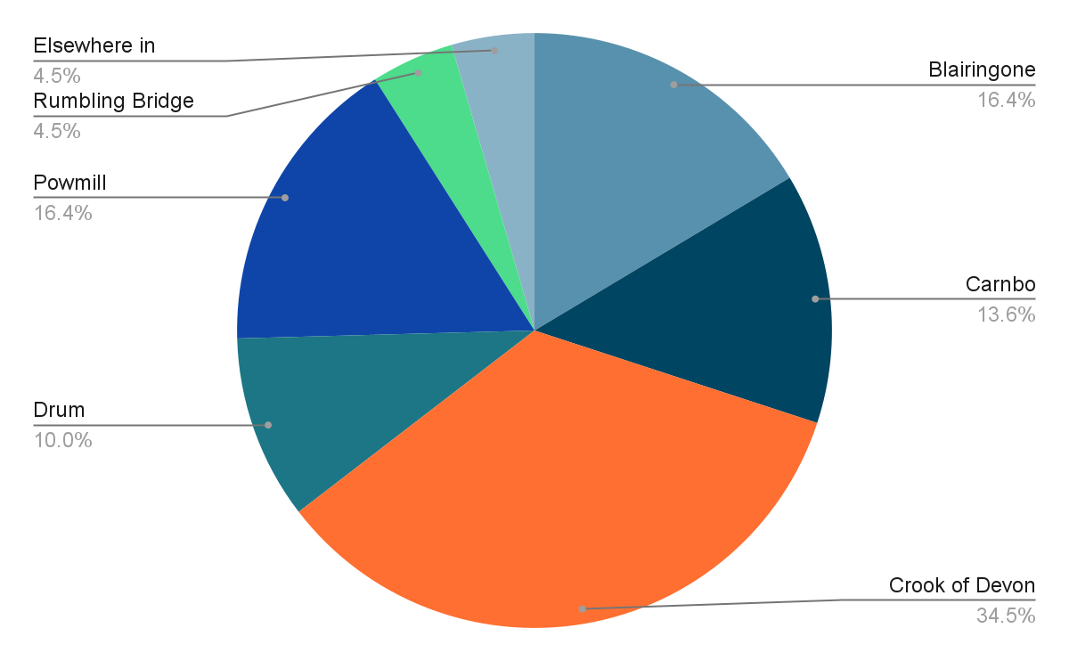

Number of Responses from each Settlement
Blairingone | 18 | Powmill | 18
Carnbo | 15 | Rumbling Bridge | 5
Crook of Devon | 38 | Elsewhere in Fossoway District | 5
Drum | 11

The majority of households that responded to the survey were from Crook of Devon although this is to be expected as it is the largest settlement in the Fossoway District.

- Tell us about your views of these proposals in the construction phase.
There were 90 responses to this question equating to 82% of total responders.

Summary Blairingone - 15 Responses
Irrespective of whether residents oppose or support wind farms in the Ochils they all raised the same concerns regarding the construction phase and that is the additional HGVs on our local roads, many of which are narrow and some single track. The disruption to local communities is a concern although it is recognised that this will be over a defined period and it is hoped that developers would work with the local community to minimise disruption.
Summary Carnbo - 13 Responses
As Carnbo will be the most impacted community during the construction phase then as expected there were a large number of detailed comments. The primary concern is the current lack of information on the construction routes from the M90 via the A91 to the proposed sites. Local roads are heavily used by walkers and many are narrow with no pavements. Also the tonnes of materials required for the construction of new access roads could have an even greater impact on the environment than the turbines themselves and this must be considered in any planning decision; especially the requirement for a properly constructed SUDs. It will be essential that there is careful planning and management of traffic to limit disruption to the local community.
Summary Crook of Devon - 28 Responses
Residents of the Crook of Devon are concerned about the additional HGV traffic through Carnbo and raised the same concerns as Carnbo residents. In addition they are concerned about the disruption to the local area when the wind farms are dismantled at the end of their lifetime and seek assurances that this will also be carefully managed and that there will be continued local stakeholder engagement.

Summary Drum - 9 Responses
Residents of Drum raised similar concerns regarding traffic concerns and local impact; in addition they also raised concern about the environmental impact of temporary construction buildings and quarrying for construction materials - especially on local wildlife
Summary Powmill - 16 Responses
Like other settlements Powmill is primarily concerned about the impact of large HGVs on the rural Carnbo community. They are seeking assurances that roads will be kept clean and potholes routinely repaired.
Summary Rumbling Bridge - 5 Responses
Residents of Rumbling Bridge, whether opposed or supportive of wind farms in the Ochils are concerned about local disruption due to the large number of HGVs and the speed of these vehicles; although acknowledged that this will be for a defined period.
Summary from Elsewhere in Fossoway - 4 Responses
A resident from elsewhere in Fossoway has sought an analysis of the amount of CO₂ produced in the construction phase and how this is offset in the future from the clean energy created from the wind farm. They also proposed that wherever possible local materials were used to restrict CO₂ from transportation and that this should be prioritised over cost. It was also noted that the technology should be improved to give a life span of at least 100 years. The resident noted that we still have operational lighthouses that are over 200 years old and they are sited in extremely harsh environments.

- Tell us about your views in the operational phase.
There were 87 responses to this question equating to 79% of total responders
Summary Blairingone. - 14 Responses
Those that oppose wind farms are sceptical about any reduction in energy costs being seen locally. But supporters see the benefit of clean energy.

Summary Carnbo - 13 Responses
Residents in Carnbo will be most affected if the wind farms are constructed and during the operational phase they are concerned about noise and light pollution. In addition the uncertainty of the route of access roads and their use once construction has finished could impact the quiet rural community. Those that oppose the wind farms are concerned about the impact on house prices as they purchased their home in a quiet rural community with beautiful views of the Ochils. Others want to ensure that the Ochils and wind farms are accessible to walkers. Local residents are seeking an assurance that at the end of the lifetime the environment is restored and biodiversity enhanced.

Summary Crook of Devon - 26 Responses
Residents of the Crook of Devon who oppose wind farms raised the same concerns as Carnbo. In particular they raised the concern of the number of birds that could be killed by the blades. Residents are also seeking a type of Bond to commit Developers to sympathetically dismantling turbines at the end of their Life. Those that are supportive asked that Developers enhance the biodiversity by planting native trees on lower slopes and footpaths.

Summary Drum - 9 Responses
Like other settlements residents of Drum are concerned about the visual, light and noise pollution during the operational phase and the impact on wildlife. They are also seeking assurances that access to the area will be maintained for walkers. Supporters look forward to a green source of energy.
Summary Powmill - 16 Responses
Residents of Powmill have the same concerns as other settlements. In addition supporters of the wind farms want to ensure there is continual engagement with Developers during the operational phase to ensure biodiversity enhancement plans are fully met.

Summary Rumbling Bridge - 5 Responses
Residents that support wind farms propose that in time the turbines will be a nice addition to the landscape whilst opponents view them as an eyesore.

Summary Elsewhere in Fossoway - 4 Responses
Residents elsewhere in Fossoway that oppose wind farms believe they will adversely impact the landscape.

- If these proposals go ahead, there will be a community windfall; how would you like to see that money spent?
There were 100 responses to this question equating to 91% of total responders
Summary Across All Settlements - 100 Responses
The responses from residents to the questions on how any community benefit fund should be spent were largely consistent with few geographically specific views. There were several comments that any community benefit fund should be viewed as a bribe and that the Community Council should not devote any time to this. However the Community Council believe that this question was essential as part of the survey to ensure that if any of the wind farms progress and are approved we are prepared to engage in a meaningful dialogue on how any fund is used.
Several residents suggested that a Community Trust with an independent Board should be set up to manage any funds. It is interesting to note that many residents are not aware of the existence of the Fossoway Community Development Trust Ltd which is a registered charity. It will be essential that the Trust is better publicised.
Village Halls & Community Spaces
As a District we have Village Halls in Carnbo, Crook of Devon and Powmill which are run by volunteers. There was a consensus that funds should go to the existing Halls in support of greener energy solutions and decarbonising our community assets including the Fossoway Primary School. Funds should also be used to enhance our Community Spaces.
Blairingone School
The Fossoway Community Development Trust is in the process of seeking funds for a feasibility study on the financial sustainability of the Trust leasing or purchasing the Blairingone School. Residents of Blairingone would like funds used to support this.
Bridge over River Devon
Several residents suggested that funds be used to replace the bridge over the River Devon that was washed away.
Local Housing
It was suggested that grants should be made available to local residents to support decarbonising of homes. These could be in the form of matched funding and/or means tested. In addition funds could be used to support development of affordable housing for local young people.
Facilities for Local Residents
Several residents requested that improvement in playgrounds and youth facilities be funded along with a request for much needed local childcare groups. Facilities should also be improved for the elderly in our community with a focus on improving health and wellbeing. The latter is a key component of the Business Case for the community asset transfer of the former Blairingone School.
Several of our rural settlements have no shops and very limited or non-existent access to everyday services such as Post Office, banks, etc. Funds should be prioritised for enabling visiting shops and services to all of our rural communities. In addition funding to support a reliable public transport system similar to that of Glenfarg should be prioritised.
Roads, Cycle Paths and Footpaths
There were a large number of residents who supported the funding of improving our cycle and footpaths, including improved signage and way markers. Providing safe links between our communities and improving accessibility for all to our areas of natural beauty would support the vision of improving the health and wellbeing of our community.
There were several residents who supported spending some of the funds on improving traffic calming measures on the A977 and A91 and improving the maintenance of our roads and footpaths. The view was that this has been adversely impacted by Perth and Kinross Council budget cuts. Conversely many residents sought an assurance that the funds would not be used to cover Perth and Kinross Council budget shortfalls leading to a reduced service. This is likely to always be controversial.
Energy
Many residents supported a scheme that provided a discount to local residents on their energy bills which could be based on closeness to the wind farms. Some believe that such a scheme would not be workable and therefore if the wind farms do go ahead more details of any schemes would be essential.
The provision of non-profit EV charging points in each of our communities was another funding suggestion.

Investment
A resident suggested that some of the funds could be invested in Government 30 year Bonds providing the community with an income.
Lastly it was suggested that there must be a simple funding application process to ensure that the many local volunteer based organisations can easily access the funds.
CONCLUSION
The survey was distributed to all households in Fossoway District and 110 responses were received equating to 11.7%. The majority of households who responded support renewable energy but opinions are divided on onshore wind farms in the Ochils; with opponents concerned about the impact on the landscape and supporters believing they are essential to halt climate change.
The findings have provided good insight into residents' concerns during construction and operation of any wind farms that receive planning permission. This information will inform all Community Council responses to any planning application. If any application is successful the survey findings on possible use of community benefit funds will be used in any discussion with planners and developers.

APPENDICES
APPENDIX 1
Question 6 – Why do you Hold This View?
Blairingone – 17 Responses
- Concern that the Ochils could be covered in wind farms. We already have three.
- Environmental protection and ensuring the future energy requirements for the country
- Happy to use green energy so should support us harvesting it
- Here in Scotland you have lovely views, unfortunately the big turbines obliterate those views. Which they are doing all over the countryside.
- If we are to decarbonise, in the absence of building considerable new nuclear capacity (actually my preference), we have to build wind/wave/solar as part of a combined generation solution. If we want renewables, they have to be built where they are most effective, and I'm certain the solar/wind companies have done a vast amount of modelling to determine the optimum locations.
I don't find wind farms unattractive and for all there have been a lot installed in Scotland, I'm personally getting quite 'blind' to them, as much as most people are to high voltage transmission lines all over the place. I actually find them reassuring in the sense of them gently harnessing the energy with very little environmental impact.
Also, I'm of the view that if you want to see renewables happen at the pace we need them to, it’s very hypocritical to say 'only if they aren't near me / I can't see them / not in my backyard'.
- Less impact on environment
- Negative effect on the landscape and environment
- Not sure of impact this will have on where we live
- Placed correctly wind farms are “almost” pollution free and arguably a complementary piece of art on the landscape. If the proposals are drawn up correctly, sustainability of the natural environment immediately impacted by the construction works should be, as a minimum, rectified and furthermore enhanced. How can we as a community not do our part to contribute to net zero!
- Spoils the scenery, and wildlife.
- The Scottish Government wants to encourage tourism and is doing everything to ruin its countryside which is its asset. Off shore is surely the answer. Also - where is the room on the national grid for all of these expansions?
- There are already enough wind turbines in the Ochil hills, spoiling the scenery and a blot on the landscape.
- They are a blot on the landscape.
- They are the biggest con and white elephant out. There are already wind farms in the Ochil Hills and several winters ago there was a period of cold frosty weather when power is most needed and these turbines never turned a blade for over six weeks.
Also when the wind is too strong the land owners and power companies are still handsomely paid from the public purse to shut them down. It is a total disgrace.
One good nuclear plant could have provided enough power and prevented these monstrous eyesores from spoiling our beautiful countryside.
- To mitigate climate change we need more renewable energy
- We don't need any more wind farms; it's time for a mix of other renewable energy sources.
- We need to exploit green electricity for the good of the climate.
Carnbo - 14 Responses
- Both developments are at an early stage and not all relevant information is available. It is assumed that the assessment and planning process will identify major biodiversity effects, likely to include avian flyways and peat, and that these will be fully addressed.
Neither developer has as yet produced any details of how the sites will be linked to the National Grid and what further infrastructure will need.
At this stage, there are three main factors, though others may emerge during the assessment and planning process.
1. The cumulative effect of turbines in the Ochil Hills.
The Ochil Hills have two areas of wind farms at present, one a multiple development site with a further proposed extension, and a third site to the east above Glenfarg. The two proposed windfarms here would visually link these, leading to a skyline dominated by turbines.
2. The number of turbines in the current proposals.
While both proposals are being modified as they pass through the planning process, it is clear that a large number of turbines will be clustered in the eastern Ochils. This represents an overdevelopment of a low-key landscape.
3. The size of the proposed turbines.
The proposed turbines are all close to 200m in total hight, over twice the height of the existing turbines in the west Ochils. These will dominate an area of low rolling hills and be visually obtrusive from a wide area, including settlements and the M90, the main arterial road north from Edinburgh to thr north. The turbine height may also necessitate aircraft lighting, leading to 24 hour/day intrusion, but this has not yet been fully addressed by either applicant.
- Don't think it will benefit me. Most of the work equipment is not going to come from the UK
- Feel the proposed wind farm sites will have a detrimental impact on the natural beauty of the area.
- In principle I support renewable energy, so it would be cynical of me if I only supported developments in other geographical areas.
- Kinross-shire has protected its views and skyline for a long time. It is part of the reason we live here. It gets visitors because of this and if the skyline is industrialised with windmills it will affect this. There are alternative locations offshore which could be used without the visual impact on the scenery that Scotland is famous for.
- Minimal disruption and we all need to contribute
- Not green when components unable to be recycled etc.
- Not sure how 'green' they are. Turbines imported. Only last circa 20 years. Local jobs - advised not at meeting. Concrete is not 'green' and a total eyesore in an area of beauty where a lot of people live. Believe company who own them are foreign (Australian pension fund). How does this benefit Scotland and locals? Not as 'green' as told, but ticks boxes for the government
- Our national future depends on developing alternative energy sources. Many vistas throughout Scotland include wind farms of varying turbine density. With thoughtful planning, selection of turbine design and heights the visibility of turbines can be less disruptive than at sites constructed in previous years. The use of 220m turbines is a purely commercial decision by the site owners. To maintain the designed power output from both sites can the owners be persuaded to reduce turbine heights and increase the density thus retaining the designed output and would the planning authorities consider such changes? This course of action will increase the through life cost of the project which the owners will be recover in some manner - does the recent Westminster Autumn Statement tax action on full expensing have a positive effect on these projects.
- PKC appointed a well-respected landscape consultancy to advise on the capacity of the landscape in the Ochils to support windfarms. They concluded it had the capacity for one windfarm; we already have three and a perfusion of individual turbines in and around the Ochils. Previous schemes proposed this area were rejected at appeal. From the existing fleet of turbines there have been no tangible benefits (local employment, opportunities for local SME etc.) and I expect the profits to be funnelled to entities in Switzerland and Ireland. I deeply resent the tactics of Galileo of reducing the size of their scheme to <50MW, this is just a ruse to get planning permission ahead of E-Power and will no doubt be rapidly followed by an application to extend (this was the same tactics used by private opencast coal mining companies through the 70s to mid-90s for opencast mines around Kelty, Lochgelly, Crossgates and in Clackmannshire)
- Previous applications have been refused. I believe the proposals are contrary to planning policy. The applications are deceptive, ie visual impact is being underplayed - turbines will in fact be seen for miles around across the Forth etc. Damage caused by construction, particularly areas of peat, release of phosphorus, fuel contaminants other chemicals from ground works which will impact Loch Leven. Will lead to over development of the Ochil hills landscape - several simultaneous competing applications with no coherent plan or strategy. There is no clear commitment on community benefits - these may take years to come to fruition and are only a benefit if a community group wants to use the funds. The applicants should be coming forward with proposals to improve the area and minimise impact make the landscape more accessible. I do not believe on shore is a viable long term solution to the climate crisis when we could start by insulating homes, fitting solar to homes, fitting better heating systems etc. - this investment should be made from ground level up not top down with overly expensive wind farms.
- This is a highly populated area of central Scotland and they will devastate a beautiful area. Wind turbines should be situated in very sparsely populated areas or preferably offshore, Scotland is already self-sufficient in renewable energy and if more licenses are granted these are purely money grabbing on the cheap for the companies. Sight them offshore, they'll still make money. Don't ruin this area.. once they are up they'll be there for 30 years!! And then they'll apply for more. The incentive for the communities is small when split. If they get the license to go ahead the communities should get way more and people who live close to it should get free electricity.
- We absolutely must do everything we can to stop burning fossil fuels and the current wind farms will lead to more efficient sustainable solutions in future.
- Wind power should be offshore, not desecrating our countryside.
Crook of Devon - 35 Responses
- Abundant green energy locally
- Because they spoil the look of the countryside
- Blight on the landscape. Would be much better if they were camouflaged.
- Concerned about the accumulated effect of several wind farms in one small area. The size of the turbines and the effect on wildlife is also a great concern.
- Costly to build. Profits to Australian pension fund. Not built in Scotland. Not using Scottish labour to build. Short life span. Carbon footprint of a truck. Look shit. All about companies making money.
- Energy security and environmental benefit
- Full support of renewable energy projects.
- I am strongly opposed to wind energy developments. I believe their benefits are overstated, they are costly, unreliable, and are a proven harm to wildlife including insects, birds and bats. They require large-scale expansion of pylons in the transmission grid, impose massive visual blight on cherished landscapes and destroy jobs - i.e. their net employment balance is negative, for each job created in the wind industry, a greater number are destroyed in the wider economy. With respect to the developments proposed locally, the Ochil Hills serve as a vital recreational area for both local people and for people from Glasgow, Edinburgh, Stirling, Perth, Dundee and beyond. They are also of environmental importance, with many protected species and peatlands. This area should not in my opinion be subjected to further wind energy developments - particularly given the insignificant contribution made to our energy requirements made by the wind farms proposed for the Ochils. Craighead for example with nameplate capacity of 48MW at typical UK load factors would scarcely produce enough electricity to charge simultaneously 40 Tesla electric cars. Moreover, data outwith the UK demonstrate that wind energy is not particularly efficient in reducing carbon emissions from electricity production. Denmark has deployed wind turbines to 1.068KW/capita (the UK would need to triple its number of turbines to reach this level). Yet Denmark's electricity remains stubbornly carbon intensive (180Kg/MWh). Wind turbines also require back-up generation plant MW for MW to provide cover for windless days, - in 2022 the wind did not blow enough or at all on 262 days - as such wind farms cannot be considered as an alternative to any other type of generation.
- I fully support wind farms but I am concerned about the larger size of these turbines and there subsequent impact on the surrounding environment. It is purely the size of these that has caused me to not fully support the development
- I recognise the need for drastic action. I want to safeguard our environment. Pleasant situation needs careful handling. Can we build windfarms and still preserve our beautiful countryside e.g. size and number of structures impact on locality. We must not delay
- I support renewable energy projects to reduce global warming.
- I understand the need for more renewable energy and would prefer it wasn't in the Ochils but obviously it has to be somewhere.
- I understand why people object i.e. it spoils the view. It is too late for that now. If we don't get our finger out now there won't be a view anymore
- June 2004 PKC stated only one windfarm should be in Ochils west of the M90. Since 2012 we now have three large windfarms operating. Current Craighead proposal on site of previously refused Mellock Hill proposal after CC objection when turbines smaller so CC should be objecting to larger turbines as contrary to PKC guidance. In your survey you don't mention above background, don't mention landscape designations for the Ochils or the support for a regional park initiative. Also failing to mention absence of landscape policy in NPF4. You should be highlighting bad policy rather than giving support!
- Ochills have special landscape character. Developments east of existing Greenknowes should be opposed because of significance.
- Onshore wind farms should not be built in areas of high scenic value. The Ochil hills are special and should be protected from such development that after all is only done for profit. Without its scenery Kinross-shire would have nothing to attract visitors to the area and would drive locals, like myself, have lived here all their days to leave for parts of the country offering better protection to the landscape
- Renewable energy
- Renewable energy is good for environment
- The economic case for wind turbines of this sought is not made out. There is no satisfactory evidence of the amount of electricity which will be delivered to the grid, as opposed to that generated at source. The production of electricity is wind dependent and unreliable. There is no guaranteed provision for the cost of dismantling the turbines.
- The long term damage to environment and ecosystem of this type of development is not worth the short term gains.
- The Ochil hills are beautiful why spoil them
- The power has to come from somewhere and if it can be generated closer to the point of use it is more efficient with lower transmission-losses.
- The world is burning; we need to do everything possible to slow the climate crisis.
- There are enough Wind Farms in the Ochils as throughout Scotland present Wind Farms are generating enough Electricity for Scotland.
- To make our communities sustainable, we must localise our power generation. This means generating as close as possible to point of use, i.e. directly on buildings. Continuing to give away tracts of land for small, short-term financial incentives is merely fuelling the capitalist bonfire of the planet.
We need to stop using fossil fuels, and unfortunately current renewable technology requires fossil fuels for its manufacture and transport. It has a limited life, at which point, we will require fossil fuels to build replacements. [see Eco-Heterodox Perspective on the Renewable Energy Transition - Rees, Siebert
https://www.mdpi.com/1996-1073/14/15/4508/htm]
Lastly, I don't believe the rights of the non-human community who would be affected have been taken into account.
Thank you for the opportunity to voice my opinion.
- Visual impact is unclear.
- Visually awful. Will be seen from many miles. They should be looking at offshore
- We are in a climate emergency. We need alternative sources of power. It is a bit unfortunate that the two proposals are essentially side by side and will provide more of an impact on immediate residents.
- We have seen the world burning we need to do something
- We need renewable energy. In order to avoid being a NIMBY (not in my back yard), I strongly support sharing the responsibility of the disruption. I'm a YIMBY. Yes in my back yard.
- We need to move to renewable.
- We support renewables in order to have some impact on climate change (our electricity is all from renewable sources)
- While I strongly agree with renewable energy, I oppose the use of onshore windfarms. The technology is highly inefficient; it does not generate electricity when there is not enough wind, and is equally inefficient when the wind is too high as it shuts down because we do not have the infrastructure to support it. This coupled with the huge negative environmental impact caused by destroying land, using thousands of tons of reinforced concrete (very bad for the environment), and the impact on wildlife, particularly birds means I would never support its development. In addition to the reasons listed above the unsightly impact of the windmills and blades would have a very negative impact on our stunning environment. I believe that more money and easier access should be invested in helping people install better insulation in homes and businesses, solar panels and ground source heat pumps. There is a constant barrage of companies saying you are eligible for grants but trying to get clear, professional, unbiased and honest advice is not always easy, which is something that the community council could look at coordinating.
- While Westminster holds such power over renewable energy licenses, we need to do everything we can at a local level to ensure sustainable energy in our communities.
- Windfarms are a blot on the landscape. They are not economic and rely on subsidies. They are only able to operate between a certain range of wind speeds. They are not green. They need 100s of tonnes of concrete as a foundation, concrete that remains in the ground forever. A heavy duty road way is built to facilitate the lorries and cranes needed for construction
Drum - 11 Responses
- Anything that removes the need for fossil fuels is a good thing.
- Having seen increasingly frequent footage of catastrophic flooding and wildfires both in Scotland and around the world I do not understand how any intelligent person can either decide to do nothing, or else demand that the necessary action be taken by unspecified ”other people”. Our district, whilst still being lovely, already has smaller wind turbines, a large number of massive pylons, poles for domestic electricity supplies etc. Most of us barely notice them and within a short period of time the proposed wind turbines would likewise become part of our background that we barely notice. I think it is unacceptable that we as a community are not prepared to do our share for what is called a “climate crisis” for very good reasons.
- I am in favour of any actions that can be taken to reduce our carbon footprint and from the evidence I have seen generally support onshore windfarms as an option however I am not sure that it is in the best interests of the future of the Ochils as a landscape amenity and destination that more windfarms should be positioned there or that there should be multiple sites along the Ochils
- I'm supportive of renewable energy however am concerned as to the impact of having two such proposals right next to each other, and in an area close to where there are existing wind turbines already in place. The Ochils are not a big area and this seems to be an excessive number. I am concerned this will restrict access to this beautiful area as well as cause significant disruption during development. I am also concerned about the potential noise and visual impacts to the community, and the close proximity of these to several villages in the area, Carnbo in particular.
- Only support in less inhabited areas
- Onshore wind energy is necessary for Great Britain to achieve net zero
- Onshore wind farms are simply industrialisation of the countryside. People who live in cities support them because they get the benefit without the downside. They don't realise the downsides.
- The destruction of wildlife habitat
- There is no choice when it comes to the environment. We must do everything we can to combat climate change and a few NIMBYs who complain about the impact on the view should be told where to go and put their stone-age views. As it is I actually like the view with wind turbines on them. Especially in places like the Ochils where the views aren't actually that impressive, yes they are nice, but nothing to write home about.
- We need to get on with taking steps to accept renewable energy
- We need to transition URGENTLY to low carbon energy sources
Powmill - 18 Responses
- 1 - short lifespan of the turbines 2 - disposal of turbines - presumably landfill 3 - not entirely convinced about climate change 4 - we need better infrastructure to meet the needs of locals ie traffic
- Already a windfarm on the Ochils. There are three new proposals which would destroy the outlook and form of the hills. There could be more to come especially because of Scottish Government policy. One is enough.
- As oil declines power still needs to be generated, given the SG attitude to nuclear we have few options.
- Because they are proven to work and are sustainable.
- Climate change and moral responsibility to improve our environment
- I believe we need to harness renewable energy and we have an abundance of wind in general.
- I believe wind power is essential to stop further climate change. Also the turbines can be removed if there is a better source of clean energy in the future
- I don't believe onshore wind power is the answer and they are expensive, useless blots on the landscape.
- I oppose these windfarms as the fact they have been sold to foreign investors and we won't gain the most benefit from the unsightly mess. We are being taken for mugs and the government should be held responsible for selling us down the river. What happens at the end of the lifespan - it will be abandoned never mind the unsightly size in our beautiful countryside
- If there is no interference with walking paths or animal welfare then I don't see any problems
- Impact on the landscape, access to the hills, disruption to the local area and road damage. I feel these should be located within the Ochils, not right on the edge
- It is greatly detracting from the natural beauty and ecosystems of the hills.
- Off shore wind should now be the priority. Scotland has enough onshore farms. Offshore may be more expensive but it probably produces a more consistent supply. When the Steeleknowe farm was at consultation stage I attended the presentation in CoD hall and was assured I would not see the turbines from my property. Liars....... I can see them. Don't trust these presentations.
- The countryside ruined by these huge turbines. Also dangerous to wildlife which never seem to be considered. People living in the rural areas not considered either
- The cumulative effect of multiple proposals and the size of the turbines.
- There is a need to harness renewable energy, so need to accept there will be an impact. This can be offset by the design of the facility and the financial benefits to the local community
- We have to develop alternative energy sources
- We need somewhere for them to go. Wind farms in the area already. Don't cause any detrimental effect.
Rumbling Bridge - 5 Responses
- Eyesore and evidence suggest not that efficient, expensive and waste of energy
- I feel all onshore windfarms are detrimental to the aesthetic appeal of the countryside but (at the same time) that windfarms are a necessary part of renewables. My chief objection is that the technology is still underdeveloped. First, turbines by their nature have to be high on the skyline, secondly that the movement of the propeller style blades draws the eye to them (I understand new designs maybe in development - but nothing has happened as yet), and finally that adequate power storage solutions (for when the wind doesn't blow) are not yet available. I feel all these objections may be overcome in time - but by then we will be 'lumbered' with a huge number of very ugly interim solutions.
- To ensure sustainable energy supply, reduce CO2 emissions, decrease and eventually cease our dependence on the despicable regimes that supply much of the world's fossil fuels.
- We must save the planet and we all have to take our share or carbon neutral technologies
- We need to future proof our energy sources in a sustainable way.
Elsewhere in Fossoway District - 5 Responses
- I have already responded to this survey, but realise that there are two things that I did not cover:
1) I live on the top of the Aldie "plateau", hence "Elsewhere in Fossoway", and look directly at both sites.
2) Neither of the websites refer to the existing turbine sites at Hoodshill and Craiglaw - both are in full view of our house. It is essential that these are shown on any planning application and not just the large sites at Green Knowes, Burnfoot Hill Lochel and Binn, as, although smaller, they are established wind farm/"industrial" sites. (It is probable that there are further small sites within 15km of these proposed sites and they should also be shown.)
- On balance wind power is a sensible way of generating electricity however I believe people who will be effected (live closer) will have views and need to be listened to (their views should have higher rights than mine)
- Small wind farms (less than 10) provide local benefit but large wind farms are an eyesore in our beautiful hills
- The natural views and environment in the Ochils will be ruined. This is an attractive area for tourism, walkers with the scenery being admired from miles away. Once spoilt this will never be replaced
- The positioning of the "farms" is critical, as the southern face and skylines of the Ochils are highly visible from most Kinross shire and for miles beyond the county boundaries.
As I understood it, when the Green Knowes, Lochelbank and Burnfoot Hill "farms" were approved it was said that no more would be allowed, unless absolutely necessary. So why are these two being proposed? Are they that necessary?
It is a known fact that if there is no wind then there is no electricity, unless there is battery storage. Batteries need 'scarce' metals and the rush to obtain theses has already escalated prices and is doing environmental damage through their extraction. There is a limited supply of these 'scarce' metals and supplies will quickly be depleted; it has been suggested that the ocean deeps should be dredged for them, but, it is said, we know less about these than we know about the moon. So, what will be the environmental cost? We could lose species before we know they exist!
We do not have these metals in the U.K. and so there is the attitude of "they are beyond the horizon", so "out of sight, out of mind" and "not in my back-yard". Climate change is about the World and not just the U.K. The human race is trashing our planet through its greed. What we should be doing is reducing the world human population, not growing it.
What we need is a constant supply of electricity, not a fluctuating one. - hydro and tidal are the obvious ones; wind is unreliable.
Locally we have, as far as I am aware, an untapped source of hydro power in the five dams in the River Devon system; why is this not being used? There has to be, by law, a constant flow through each dam and that means that the same water would be used three times from the Upper Glen Devon dam and twice each for three of the other four dams. The added bonuses are that there will be no further environmental damage, the cost should be considerably less and the carbon dioxide produced during construction very considerably less.
Houses are being built everywhere and where they can’t it seems wind farms are. Do we want to live in an urban/ industrial landscape because we are greedy and unable to control our population?
APPENDIX 2
Q8 - Construction phase
Blairingone – 15 Responses
- Both appear to be away from any main settlements and would only impact the road for a short period of construction.
- Happy for construction to proceed.
- No comment
- No objections
- N/A
- Short term disruption and some local jobs expected
- They should not be going ahead.
- Consideration should be made to avoid construction using major thorough fares at peak times of the day. Construction traffic should be cleaned when leaving site to avoid unnecessary debris on the carriageways.
- Concern re traffic
- Significant local disruption
- Against this as it would lead to more HGVs on our small country roads which already struggle to accommodate heavy traffic. The size of the transport required for parts would cause travel problems.
- The Ochil hills are a natural chain of hills, wind turbines are an eyesore spoiling the hills.
- Concern about lorries and traffic and roads.
- Hope that construction side traffic and noise can cause minimum disruption for community. Any damage to roads etc. due to increase traffic/large vehicles needs to be fixed.
- Too high, a blot on the landscape, an expensive option with a high carbon footprint
Carnbo – 13 Responses
- Whilst the construction phase might bring inconvenience for locals, it's only a short term issue and I therefore consider it to be acceptable.
- Against strongly as far too much construction traffic in the community.
- These have been moderated to a much smaller number of turbines which seems proportionate
- Worried about the disruption the transportation of road construction materials and windmill parts will have on households on the route.
- The construction will see a large volume of large trucks heading towards Carnbo. It is assumed that most traffic will be coming from the east but there is no confirmation of that from either project.
Even if the traffic comes from the east there is a potential for a large increase in traffic on the B918. This is effectively a wide single track road and not suitable for lorries to pass. As the Aerospace project will also be on this road by the time the projects move to construction stage this will add additional weight of traffic that is a vital road for locals to access Kinross and M90 south.
The Craighead project will make an access on the east side of the Carnbo but near a corner. This means that lorries will be turning across the road as the road goes from 60 to 30 and is effectively used as the last overtaking zone before the village. This has the potential for accidents.
The Brunthill project intends to access the site via a temporary road on the east side of Carnbo Hall to goes north of the hall and join the unclassified road. This will be safer from a vision view point but is presently 60mph and history of fast traffic taking advantage of the straight to overtake. However the unclassified road is used by dog walkers and cyclists. The road is single track and concerns is the speed of the construction traffic and lack is passing places for local traffic using the road and wagon passing each other as they met on the return from the construction site. The unclassified road should be considered to become a Walker and cycle friendly road as it joins the existing network at Dalquiech.
- I am concerned about heavy metals sourced unethically, metals plastics and embodied carbon in the construction of these machines. The damage caused to the landscape, environment, archaeology, cultural heritage assets (which are massively under surveyed - ie no physical on site surveying has been carried out) will be irreparable. I would hope this is controlled to avoid works sprawling into other areas as often happens with such projects. I.e. Brunt hill proposes to use existing tracks; however they have admitted these will be required to be completely re built. However so much damage has already been caused by forestry I appreciate their logic in keeping turbines to forested areas which in themselves are sterile green deserts with no biodiversity. A further point ignored by developers is possible overhead lines - a firm commitment to what will be required is needed.
The open heath and grazing of the Ochils should be protected and enhanced at all costs.
A lot of the archaeology of the Ochils has not been recorded with HES with them favouring more interesting landscapes such as Highlands and Islands. The applicants need to do a proper on the ground survey - structures such as the waterside bridges could be erased entirely during works with nobody's knowledge.
- Roads from motorway totally unsuitable for proposed movement of construction needs
- Should any wind farm gain approval the construction phase has an impact as site access from the public highway and on-site haul roads are created. This is an inevitable consequence of the approval. There is limited access from the A91 to either of the sites under consideration. Access points from the A91 should be permanent features constructed in accordance with the relevant highway design requirements. Once vehicles depart the A91 the haul roads should be planned and routed to; avoid creating obvious scarring of the Ochils, include appropriate drainage that avoids run off and to a design that, with routine maintenance, will last the life of the sites.
Erection of the turbines will generate some heavy and outsize load traffic. Planning and public notification will be necessary to maintain community support.
The site preparation phase will occur off the public highway and with limited heavy equipment. It is my view that with careful planning and management there will be limited disruption.
- The proposals available at present do not contain much detail on access during construction, other than general positioning of two major access roads in close proximity off the A91 near or in Carnbo. Neither developer was able to discuss the access routes to the sites are the consultation meetings. There is no evidence that full consideration has been given to the movement of the huge structures involved through the restricted roads in the area.
- Obviously someone will make money from selling ground for access, but will be a big mess & lots of heavy vehicles through a small village - too close to a populated area. If have to be onshore, surely don't need to be in such a highly populated area
- I would expect that the design would incorporate SUDS drainage to ensure that hardstands/roads do not increase the risk of additional downstream flooding stress and protect any peat. Connection to grid by buried cable.
- I think there will be significant disturbance to local communities initially
- If this goes ahead then the construction phase should disturb local communities to the minimum. I don't know enough about what they plan.
Crook of Devon – 28 Responses
- Make them less obvious
- Construction should offer some employment in the area and the construction site should not affect local residents.
- Renewable energy is good for environment
- Support, if the immediate neighbours are on board and get some benefit/recompense. I'm also keen to make sure that it doesn't create more overhead pylons as these can have health and environmental impacts.
- Hopefully engage local stakeholders
- As stated above, I strongly oppose the development of inshore windfarms for the reasons stated above. The disruption caused by large vehicles going to and from site during construction caused short term frustration but it is the longer impact that concerns me.
- My only concern would be proper dismantling of the site at its end of life. I'd like to ensure there is commitment and financial provision for this.
- Hopefully engage local stakeholders
- Go a bit slower to cause a bit less disruption.
- None particular
- I am concerned about the level of construction that will be required and its impact on the area. I question about any other constructions required i.e. How is the Windfarm connected to the grid? Will there be underground works or pylons? Any works will not just be in one area.
- Proper traffic management controls should be in place
- I would prefer these developments not to be constructed at all.
- Won't really affect me so no strong views.
- I have no issues regarding these
- I don't know enough to make a helpful contribution here, other than hoping that locally sourced labour and materials are used.
- I think will cause transport and traffic problems during the construction phase, also upsetting the wildlife diversity in the areas of construction.
- Permanent destruction and damage to environment and local area
- Traffic problems, congestion, noise, pollution, damaging the environment
- Construction will cause great disruption on our roads as well as irreplaceable damage to the open hills through building of access roads and concrete bases.
- I don't know enough about construction phase. Hopefully plans will fail so no construction.
- I would hope that any road adjustments would be rectified after. There is a concern that if roads were permanently widened then traffic would increase along the road to Carnbo
- Strongly oppose
- Don't know enough to comment
- 1 - minimise nuisance to locals 2 - minimise damage to nature and heritage 3- minimise disturbing peat
- I am deeply concerned about the devastation of the countryside and its scenery which will have a devastating and depressing effect on all of us.
- Impact on locality – e.g. roads, noise, local housing, size of turbines-transport vehicles, planning - information to local/general inhabitants
- Massive disruption to local traffic caused by construction traffic, lorries, concrete lorries, workers transport plus low loaders carrying the towers and blades to the location.
Drum – 9 Responses
- I am concerned about the potential volume of construction traffic that will access the site, increased traffic on A977 and A91 and road safety issues for residents along the A91
I am not sure about the option for quarrying for construction materials within the site as surely this will have a major environmental impact upon the area doing long term damage to the landscape.
- The construction phase seems to be relatively low impact.
- They should ALL be approved
- Like any construction project this is a temporary nuisance and not an ongoing problem.
- I am concerned about the logistical challenges in transporting the equipment needed, including the turbine blades themselves, and the impact this will have on the local roads and population. There will need to be access for crews and heavy machinery to build the bases, auxiliary buildings and erect the turbines, plus a significant amount of concreting to support them, again impacting local roads and communities. I am also concerned about the impact to local wildlife including red squirrel population which are a protected species, as well as White Tailed Eagles, Buzzards and other birds of prey seen in the Ochils, both during the construction phase and also in the operational phase.
- Please just build the wind farms before I have to see even more of my neighbours bailing out their flooded properties.
- Traffic increase on A977 and A91 to access particularly at Carnbo
- Traffic management impact on small villages
- Not only is the proposed site damaging to the environment but also the access routes.
Powmill – 16 Responses
- As always there will be disruption, which, I hope will be minimised.
- Just don't even get this far.........!
- Supportive
- Glossy half-truths to disguise the reality
- Carnbo will be significantly affected. Worries about traffic situation with huge pieces of hardware travelling down country roads. If fields were taken over to ease access concerns around mud and dirt on the roads too. Concerns around damage done to the hills simply in terms of heavy duty vehicles accessing them.
- When the current pylons were put in there was construction along with every road, pipeline, water main, housing development, motorway etc., etc.
- Big concerns re numbers of vehicles travelling along local roads, road damage and who pays for this caused by HGVs+++, which roads will be the access roads?
- None
- They will be clearly visible
- I think the proposed area to be developed is too close to existing houses.
- Should ensure there are clear plans with accountability to mitigate disruption to local community
- I think it will be disruptive for the communities closest to the proposed sites
- There is going to be a great deal of upheaval in preparing access routes for the transport of the huge blades and an increase in traffic on narrow country roads with construction vehicles and machinery accessing the site.
- There will be disruption of cause but it will be worth it in the long run
- Ruin the landscape, affect wildlife, cause land disturbance
- We live in a quiet community that will be totally disturbed during the construction. Who is paying for the damage to the already pot holed roads? There will be constant trucks destroying our peace and quiet. We already have the quarry development and the building site in Powmill disturbing us for years.
Rumbling Bridge – 5 Responses
- Local disruption should be kept to a minimum and good communication is required with local communities.
- I have no particular views
- So long as the lorries are travelling at a respectable speed, there should be no issue
- Presumably there'll be some disruption due to heavy construction machinery, but in my view, a price worth paying.
- Strongly object, construction eyesore. Only benefiting are the foreign manufacturers
Elsewhere in Fossoway District – 4 Responses
- This phase is hugely CO2 productive and environmentally destructive.
Two facts need to be established completely independently of E Power and Galileo -
1) What is the total amount of CO2 and other green-house gases that is going to be produced during manufacture, transport (presumably half-way round the world) and the site work (earth works, foundations, fabrication and cable connection to the grid)?
2) What is the power output based on the actual output of the neighbouring wind-farms already referred to in 6) above? The CO2 saving can then be reasonably accurately worked out. ("Enough to supply xx houses/homes means nothing. I suspect that if all the "suggested/estimated" 'houses powered' figures for the existing, under construction and plan approved "farms" (on and off shore) are added together then we will be well on the way to supplying our total needs.)
There are two things that should be mandatory; if a real long term benefit is to be obtained -
1) All major structural works should be made within the UK, thus saving on transport CO2. The climate is more important than the cost saving.
2) The technology should be improved to give a life span of at least 100 years. Look at our light-houses built over 200 years ago, often in places of an equal or harsher environment and they are still good for another 200, if maintained!
The attitude to relatively short lived structures must be changed very quickly, otherwise it would not be the climate that is the concern - it will be, are there enough materials?
- Won't be directly affected by building work
- Disruption to locals in many ways - travel, noise, nature, wildlife, peace of mind, damage to tracks and walking routes
- There will be congestion and damage to public roads during the construction phase. Jobs will be created
APPENDIX 3
Q9 – Operational Phase

Blairingone - 14 Responses
- I have no particular view. They will be there, turning, generating electricity. I may see them on the horizon but that wouldn't bother me.
- Will be happy to see the scheme progressing.
- No comment
- no objections
- N/A
- Little long term impact
- They are too unreliable.
- Happy
- Is the amount of energy generated worth the significant devastation to the environment and wildlife
- They spoil the landscape; they are huge and look awful on the skyline. Ruins the Scottish countryside.
- Where is all the cheap electricity we were promised after all the wind blows free. It’s one big con to fleece the public again. It won't make any difference what the public say it will go ahead anyway.
- Concerned about noise
- Hope that noise from turbine and traffic can be minimal and not impact on surrounding properties.
- I would like the proposal refused
Carnbo - 13 Responses
- I have no strong feelings.
- Concerned about noise.
- It will be tricky on occasions and I have sympathy for those closer to the access road but a necessary part of developing a sustainable energy source. I live in a v old house and heat pumps etc. will not work for me.
- Negative visual impact, disturbance of wildlife, noise pollution
- The concern is the amount of traffic after the construction phase is over. There is little information on this.
It should be noted that the Brunthill project consider the new road to the east of Carnbo Hall will removed after construction. This will result in an increase in traffic on the section of the unclassified road to the West of the schoolhouse and hall in Carnbo. This road is narrow and a tight turn. Already lorries have to mount the pavement to get up the road and larger traffic coming from the west has to swing across the A91 so they can go up the lane. This is becoming an issue now as agricultural vehicles have become longer over the years the additional traffic for the windfarm could cause major issues at the junction. Should the new road proposed be kept for the duration of the life of the windfarm this would offset this.
- I am concerned about the short life span of these structures and how they might be recycled. A commitment needs to be made to restore the ground when they become fully redundant which may happen sooner than later. I am concerned we are seeing an industrialisation of the Ochil hills. I am concerned this will be over development. I am concerned that access to the landscape will be inhibited - if this dire situation goes ahead we must ensure access to the Ochils is enhanced and improved.
- Once operational the sites will be subject to routine maintenance. The traffic volumes should be negligible.
- Other than visual impacts, there should be few impacts on local communities in any operational phase, though careful planning will be needed to ensure that this is the case. Both developers should produce an access plan for their proposals, showing how they will ensure and enhance public access to the sites.
- Main issue is the view. Trying not be 'not in my back yard', but not sure there are any benefits, apart from saying we are putting in wind turbines...sounds good until you ask detailed questions! What about value of property? Bought house with beautiful view, but will be no longer, compensation not on offer.
- Full bond submitted to PKC for full restoration of the site. Developers to fund comprehensive scheme to manage extraction of timber using their access roads to take timber wagons of the wee country roads (Muckhart-Dunning, Milnathort,-Path of Condie-Dunning and Milnathort -Path of Condie -Forfandenny) direct to the A91, A9 and A823
- Whilst they will undoubtedly change the outlook for many these turbines will eventually become an accepted part of the landscape
- I worry about the lights at the top of wind turbines blinking all night for aircraft. Will this be visible to the whole community if they look to the Ochils?
Crook of Devon - 26 Responses
- Make them less obvious
- Will support Scotland’s renewable energy goal.
- Renewable energy is good for environment
- As above, broadly supportive subject to their maintenance and investment in the local infrastructure which the suppliers will be using e.g. roads.
- Ensure well supported
- None
- Ensure well supported
- Keep the community informed of successes and problems.
- Visual impact is an issue but also the variability of wind power - is it really viable?
- I don't have an objection to the windfarm in principle but question the height which seems very high compared to the highest of the surrounding hills. Can the developer provide some other environmental benefits as well such as native tree planting on lower slopes and footpaths?
- I have concerns about the impact on the landscape, noise/light from the turbines and also effect on wildlife.
- No real impact apart from visual
- Visual blight + constraint payments already running at 215 million pounds in 2022 added to electricity bills are simply outrageous.
- Won't really affect me so no strong views.
- Same as above.
- Cannot comment on operational phase as don't have the knowledge of Wind Farms operation.
- I guess the question is how operational they will be since the farms already up the Ochils sit stationary the majority of the year. The impact on animal and especially bird life is too significant.
- Noise, look grim, scar on the environment, short life - it’s all about company profit. Not actually green at all - ask Germany
- They will just be an eyesore
- Views, wildlife, noise
- If they go ahead then wildlife and noise impact would be a concern. Hopefully this would be addressed.
- Strongly oppose
- Don't know enough to comment
- I am deeply concerned about the lack of information about the regular supply of electricity in ascertainable quantities and the absence of any guarantee on the cost of dismantling the turbine at the end of its life, such as a bond.
- Noise. Effect on roads - density of traffic - mud. Maintenance - vehicles -lighting etc.
- The blades kill lots of birds. This happens wherever the windfarms are situated onshore or offshore.
Drum - 9 Responses
- Again relates to access.
Do they actually need to be so tall - I am not convinced by the argument that smaller turbines will not be manufactured in the future
Where is the electricity generated going to go?
- The operational phase seems acceptable.
- I look forward to when these are active and generating electricity - couldn't come soon enough.
- The noise pollution and the damage to our lovely countryside is very long term, and this is what I am opposed to.
- I am concerned about the visual impact the turbines will have, which looking at the mock-up photos on the Brunt Hill website seem to show them visible from quite some distance, including from the M90, which could have a knock on effect to tourism to the local area. I also feel that given the main tourist route north to the Highlands for tourists arriving into Edinburgh is via the M90, these are one of the first, and the most panoramic set of hills that are visible travelling north up the M90; having wind turbines over a large visible section of this will have an impact on perceptions and could lead to less tourism for the area.
As noted above in question 8, I am also concerned over impact to local wildlife such as red squirrels, birds of prey and also visiting wildlife to nearby Loch Leven Nature Reserve such as the pink footed geese.
I also have concerns over access for walkers and riders, noise levels when operational, and any potential light pollution at night in a traditionally dark sky area (given both Tullibole Castle run star gazing events and the upcoming Aerospace Kinross are nearby).
- See answer 6
- Will developers maintain open access to area for walkers
- Visual impact noise
- Offshore facilities should be given more encouragement than land based
Powmill - 16 Responses
- They quickly become part of the landscape so impact is minimal.
- If you do as I say in question 8 then question 9 is irrelevant
- Supportive
- Probably wildly over optimistic promises that will never be met, because they never have so far.
- The impact of man-made creations on natural scenery. Implications for wildlife, birds etc. Sadness for those that live close and have to look out on them when once before where beautiful uninterrupted views.
- I don't have any. It is required as above.
- Noise, visual aesthetics, would the access be impeded. Will the company actually provide the local community fund it promises
- None
- They will be clearly visible
- I think the proposed area to be developed is too close to existing houses.
- Continual engagement with the developer to ensure biodiversity enhancement plans are met.
- I have concerns about the turbines size and the cumulative effect
- Yet another wind farm spoiling the beauty of the Ochils.
- Many times the turbines have to be switched off as there too much going through the national grid. Owners of the wind farms still receive exorbitant amounts of money
- No comment
- I totally object to the whole project. Why destroy our beautiful countryside for the benefit of foreigners we have to live here not them.
Rumbling Bridge - 5 Responses
- The wind farms will become part of our local environment and therefore Fossoway should benefit from any profits made.
- No views
- This will be a nice addition to the landscape, possibly even a tourist attraction, furthermore the money flooding in to our community will be of huge benefit
- Glad to hear of proposals for continuing benefit for local communities.
- Again strongly object - eyesore and not efficient
Elsewhere in Fossoway District - 4 Responses
- Must be maintained to maximise the life span, which should be planned to be at least 100 years +.
- Don't know enough about that as no experience
- Loss of local scenic views spoiled by the site and noise of these turbines. The loss of peace and tranquillity is so sad and cannot be replaced once taken
- Once operational there will be a visual impact possible impact to birds. Maintenance will be required

APPENDIX 4
Q10 – Community Windfall

Blairingone - 16 Responses
- As a regular visitor to France, I totally appreciate the impact of the local administrative structures there that include local mayors and budgets for local works, even in small villages. Although we can't replicate the administrative structures, I would welcome any community windfall being allocated to local investment in infrastructure:
- Properly fixing potholes in the roads, or even better a rolling programme of properly resurfacing road curb to curb rather than the regular and short lives bodges that happen every year.
- Installing proper off-highway, traffic segregated walking and cycling routes that are well maintained
- Upgrading street lighting
- Cleaning and improving signage
- Ditch clearing and drain cleaning so water run-offs work properly
- Installing attractive street furniture that could support safe routes to schools, bus stops, improved curbside maintenance and grass cutting, tree trimming, footpath maintenance etc., etc.
- Creating better village community spaces
- Just making the place look less tired and a bit more invested in so people living here and passing through can have a bit more pride in where they live
... all the stuff that has been subject to council cutbacks year on year and is more than capable of being organised (and probably done better) at a community council level if they had actual budget to spend.
- Spent on local amenities.
- I think that a distribution of cheaper power is unlikely to be workable, and shouldn't constitute a significant portion of the windfall. Rather major projects should be financed.
- fix the roads :D give to those in need
- Make sure the speeding drivers are stopped, by narrowing the roads. As most going through Blairingone think they are on a race track, or big lorries doing 50 plus not interested in 30 mile zone limits, just waiting for them to plough into the houses on the Main Street.
- Traffic calming through villages on a977. Physical carriageway restrictions, the traffic lights are a waste of time and money as they have zero effect on speeding.
- I would like to see some of it spent on the Blairingone School Project.
- Improving public transport links and path / road networks. Publicly available fast chargers for EVs with a non-profit rate. Perhaps this could be factored into the contract for the wind farms to supply such chargers at cost, I know other Renewables companies do this.
- Possible bypass for villages on A977
- Improve quality of life for local residents.
- Upgrading Blairingone school.
- Donate to Blairingone school community funds
- Community benefit schemes and cheaper electricity
- Road improvements, traffic calming
- Traffic calming narrow the main road at Blairingone to physically slow down traffic and speed cameras
- I would like the proposal refused
Carnbo - 14 Responses
- Investment in pathways and cycle paths in the Fossoway area (e.g. between Carnbo and Gelvan Moor Road). I would also like to see investment in nature reserves and similar schemes.
- It's not a 'windfall' - it's a bribe. If we have to suffer these impositions then I would suggest money for Carnbo Community hall, flower planters for all affected communities & community transport, such as the Glenfarg bus, for communities without public transport, such as Carnbo.
- Ensuring community facilities are maintained well to encourage activity - e.g. Carnbo Hall and that traffic control measures are monitored
- Discounts on electricity for households and community buildings. Financial help with installing and running greener energy solutions for community buildings.
- I support the idea of a Renewable Electricity Discount Scheme which the Craighead proposal is considering. This should be considered by Brunthill as well.
I think that there should be a project to help the community halls to move to green energy and heating. In many villages across Kinross shire the only community places are the halls that are owned and run by the communities. They do not have the money to make large investments for morning to green heating or fitting solar. It make sense to make funds from the windfarms to reduce the impact the community assets have on the environment. As each hall has multiple users it a good way to share the windfall across the community.
- This should not be part of negotiations as to whether an application is suitable or not. It is in essence a bribe. I am concerned the community council and members of the community could become distracted by the prospect of a wind fall and not judge the development purely on its merits. There seem to be no firm commitment from the applicants on windfall, and when this may even be available if ever at all - my understanding is it has to make a profit first - that may take decades. The applicants should be making proposals for simple things with their application such as improved paths, signage, way finding, interpretation to allow people to enjoy the Ochils more - our Ochil landscape is an untapped leisure resource and about to become completely industrialised.
The CC should not be fixating on financial benefits through their decision making. This can come later down the line.
The CC must focus on the PRINCIPLE of this development. The CC position has always been against wind turbines and it should remain the case.
- To benefit those who face the most disruption and those who are local
- Both sites, but Bruntshill in particular will be visible for many miles especially to the South. Indeed, as far as the south of Edinburgh. Determination of the affected communities requires coordinated action by community councils and clear guidelines as to distribution community funding. In my opinion consideration needs to be given to large projects that benefit the wider society rather than many small grants to worthy causes many of which will have limited outreach.
- The windfall amount is not yet established as the proposals change at this stage, so no comment is offered on how to spend an unknown amount!
- Believe it is minuscule per person, but people affected should be given 'free' power
- Pooled fund developed for long term capital investment in the community ....... footpaths, capital works to existing facilities, long term environmental improvements etc.
- Greater energy support for the elderly and investment in capital infrastructure for local community organisations to help improve rural cohesion
- Sensibly and wisely as jointly agreed with the local communities in a transparent manner
- On the village hall at Carnbo
Crook of Devon - 34 Responses
- Rebuild the bridge over the Devon at Naemoor Road which was washed away.
- I would like to see local charities and youth organisations benefit from the windfall.
- For the community
- I think the money should firstly be spent on decarbonising public or community assets and by that I mean the Primary School, Community Halls - these shouldn't be fuelled by oil and there is no public money to change this. Secondly the residents of Carnbo and houses really near the development should get investment in cheaper or free electricity. Thirdly, there should be funding in local infrastructure - ultra fast broadband and a fund to bring up lots of private roads in the area to public standard for adoption. There should also be funding for low income, retirees, social housing residents to improve energy efficiency in their housing - insulation, heat pumps and solar panels. Other suggestions are apprenticeships for locals, school visits and scoping for other community energy generation projects
- Children's play areas
- I appreciate that the windfarms "buy" their way into areas by providing community windfall and I have seen it doing good, but as stated I don't think for the region it is the right thing. If it does go ahead I believe an independent board should be set up to go through applications from community groups. I think what is essential is to make the application process easy and straightforward, many small charities do not have the knowledge, support and skills to make applications so providing free "guidance" sessions to provide them with the knowledge needed to make applications is essential. If this is not offered there is a real danger that they will be at a real disadvantage and the larger, local charities will be successful while money will not flow into the grassroots organisations who provide essential help to local communities.
- Fossoway school funds and development of the path network
- Children's play areas
- Biodiversity projects, safer cycle routes, community dog park, More bins!
- Affordable housing locally for young people.
- Maintaining community buildings, subsiding renewable generation in homes and businesses , assisting with fuel poverty
- Active travel/leisure network, native tree planting, local community assets upkeep and transition to low carbon running e.g. village hall insulation and move away from oil and gas heating.
- Local groups, local amenities should benefit.
- Shared with communities in a fair manner
- I would like to see the entire industry nationalised and run on a not for profit basis. I remind the CC that cold-related deaths run at tens of thousands each year in the UK and we should not support costly, inefficient and unnecessary wind farms when carbon emission reductions and security of supply can be achieved through other means more economically.
- Something that benefits the whole community rather than niche or special interest groups who just happen to be better at completing grant application forms.
- Develop community spaces
- In local charities & non-profit organisations
- Upgrading of insulation of local properties, a community cafe with sufficient funds to operate efficiently, comfortably and economically, and an NHS dentist.
- Better Local Community Transport to Stirling and Perth.
- Community health and wellness facilities. Signed walks, path maintenance bridge repairs on existing areas.
- Ideally there would be no government payouts to ruin the beautiful spaces of Scotland
But if money needs to go somewhere then
Local village hall funds,
community groups for young and old,
paths and trails,
traffic controls in area to reduce risks from RTAs, fast traffic, HGVs and fumes.
- It will amount to nothing - 0. Give us the profits the Aussie pension fund is getting and our environment
- Community windfall or 'community bribe' - aimed at those who would sell their granny for a fiver - not interested
- Trying to buy people's approval for their schemes by offering 'windfall cash' is wrong!
- Local community groups, improve facilities, wild life and woodland protection projects
- Either amalgamating with an existing funding body or a separate trust for use in the Fossoway area to improve the lives of people in Fossoway
- I don't it to go ahead
- The basics - people are caring for very sick individuals for no support. That's wrong; food bank; help with utility bills
- Should be given to the community development trust for infrastructure projects around Fossoway not private people
- No views
- Development of local transport so serve area - desperately needed. Improvement of retail facilities in the area. Wrap around childcare. Children's play area - leisure facilities
- Community benefit is a financial bribe for communities to compromise their landscapes in order to secure funding for the local authority should provide
- What an insult to the intelligence of members of the community. Any money received will be pennies and will have no effect on the local communities.
Drum - 11 Responses
- Although it is an attractive option for some people I do not think that Community Benefit Funds should be used to fund a REDS scheme. Community Benefit should be for the whole community. The potential cost will be significant and greatly reduce the funds available for major projects.
Also there is a potential that REDS payments will negatively impact the more vulnerable as can affect access to other benefits or result in income that will limit benefits
Also REDS does not encourage people to use less energy and make individual changes to consumption
If they wish to 'compensate nearby residents that should come from a separate fund
I would like to see instead funds being made available for home improvement grants such as insulation or renewable power. These grants should not be means tested or require matched funding
If either of these proposals go ahead I would like to see funds being made available to improve the accessibility of the Ochils for everybody not just keen ramblers either with a visitors centre, improved parking facilities or public transport, better footpaths etc.
Funding for improving the WALC route, repair to Bridge and establishing better connections between Core Paths and cycle routes
A Community Trust should be set up with an independent board of Trustees
- I would like the money to support further energy saving measures in the community
- Grants to those who cannot afford it to install green tech such as solar panels and heat pumps.
- If it does go ahead the windfall should benefit nearby local residents who are most disadvantaged by the construction, ongoing noise pollution, and the damage to their outlook on a daily basis. A contribution towards their electricity bills would be best. It should not be used for infrastructure improvements (roads, schools etc.) as any of these projects should be provided by the relevant authorities, and it should not be an opportunity to save them money.
- By providing grants/subsidies to decarbonise local homes. Things like insulation/heat-pumps/solar pv/pv batteries etc.
- Local community projects, particularly those focusing on conservation and education. Support for local community structures and buildings (such as village halls), provision of clubs and equipment for local children in the community (both primary and secondary age). Maybe consider setting up a central hub for Fossoway communities.
- Subsidised electricity bills
- Dealing with drainage solutions for those people who are most affected by flooding. Luckily this does not include us. Yet.
- Maintenance and upgrade to all village halls
Community bus
Large projects to benefit everyone
- School resources due to PKC budget cutbacks no simple resources pens paper money to photocopy
- Traffic calming measures are inadequately supported.
Powmill - 17 Responses
- In helping the community of my village
- Invest in 30 year gov't bonds and generate annual income, which, can be used to support different community initiatives rather than spending on a single project and thus losing the windfall going forward
- I refer to my answer in question 8
- Any windfall spend should be determined by anyone who attended Kinross High School, we must not allow the private school fraternity to push the money towards their needs rather than the interests of the general community
- Setting up better amenities for the disadvantaged and improving civic amenities.
- IF ? they go ahead. The financial benefit could be significant. Carnbo must have needs. It has no shop or public transport. Maybe a visiting shop and services if none can be established in the village with financial support. A bus put on the route. Maybe servicing Kinross, Milnathort, Carnbo, Muckhart to Dollar & Tillicoultry. Would give access from Kinross & Tillicoultry to Stirling, Perth, and Edinburgh etc. Would lessen the feeling of isolation. Other than Carnbo monies could be spent on supporting village halls, encouraging more leisure activities in them as they are so underused at the moment. Improving the general transport situation with links maybe to Alloa (rail). Funds for already existing events like the Fossoway Gathering and supporting clubs that are struggling to survive financially. They need a lifeline. But we must ensure that we do not use the money to bail out the Council and its responsibilities.
- Towards community projects that support.....the community
- Supporting a bus service like the Glenfarg scheme if the 202 continues to have poor service, provision of a fenced community woodland, donation to local school, toddler groups and sports clubs, improving surfaces of core paths and could connect up Powmill to more of the core paths
- Long term benefits for the whole community. For example, dedicated cycle path to Kinross, expanded cycle path to Dollar from Crook, AstroTurf multi sports pitch etc.
- Improvements to community assets, projects, schools, elderly assistance
- Develop community projects which improve mobility for young people.
- To benefit local community agreed projects
- Social benefits for the community
- Community upgrades to roads and amenities.
- The area is desperately in need of an after school club for working parents. There are currently no provisions in the area for wrap around childcare
- to provide amenities suited to each individual village
- We will hardly gain any monetary benefit from these - stop trying to pull the wool over our eyes.
- Rumbling Bridge - 5 Responses
- Distributed to local groups, schools and charities to improve quality of life in Fossoway.
- Spent on the environment in some way. My personal preference would be on cleaning up contamination of local watercourses.
- I’d like to see a community development trust set up to help future generations
- Improved maintenance of public footpaths and roads; vehicle-free cycle & walking routes; rebuilding of the pedestrian bridge at the north end of Rumbling Bridge Gorge.
- Elsewhere in Fossoway District - 3 Responses
- I consider this to be a bribe.
Suggestions -
Pothole free roads.
A discount on electricity bills.
Environmental projects.
- Reinstate the countryside damaged. Camouflage the sight of turbines, reintroduce wildlife and plants displaced, and donate to charities that support Perth and Kinross health matters.
- Improving road safety and maintaining paths (for walking and cycling.) Worry that the windfall is a bribe.

